A Mini Project Report
On
LAUGHING SOULS
Submitted in partial fulfillment of the
Requirements for the award of degree of
Bachelor of Technology
In
Computer Science and Engineering

by
Preeti Mandal,
(14H61A05A2)

Sri Krishna Karumanchi,
(14H61A0585)

P. Sushanth,
(14H61A05A1)

Under the Guidance of
Mrs. G. Bindhu Madhavi,
Asst. Professor,


Department of Computer Science and Engineering
ANURAG GROUP OF INSTITUTIONS
(Formerly CVSR College of Engineering)
(An Autonomous Institution, Approved by AICTE and NBA Accredited)
Venkatapur (V), Ghatkesar (M), RR Dist., T.S-500088
(2014-2018)


CERTIFICATE

This is to certify that the project entitled “Laughing Souls” being submitted by Preeti Mandal bearing the Hall Ticket number 14H61A05A2, Sri Krishna Karumanchi bearing the Hall Ticket number 14H61A0585 and P. Sushanth bearing the Hall Ticket number 14H61A05A1 in partial fulfillment of the requirements for the award of the degree of the Bachelor of Technology in Computer Science and Engineering to Anurag Group of Institutions (Formerly CVSR College of Engineering) is a record of bonafide work carried out by them under my guidance and supervision from july 2017 to oct 2017.
The results presented in this project have been verified and found to be satisfactory. The results embodied in this project report have not been submitted to any other University for the award of any other degree or diploma.

Internal Guide External Examiner Mrs. G. Bindhu Madhavi,
(Asst. Professor)

Project Coordinator Pallam Ravi
Asst.Professor

Dr.G.Vishnu Moorthy,
Professor and Head, Dept. of CSE

ACKNOWLEDGEMENT

It is our privilege and pleasure to express profound sense of respect, gratitude and indebtedness to our guide Mrs. G. Bindhu Madhavi, Asst. Professor, Dept. of Computer Science and Engineering, Anurag Group of Institutions (Formerly CVSR College of Engineering), for his/her indefatigable inspiration, guidance, cogent discussion, constructive criticisms and encouragement throughout this dissertation work.
We express our sincere gratitude to Dr. G.Vishnu Moorthy, Professor & Head, Department of Computer Science and Engineering, Anurag Group of Institutions (Formerly CVSR College of Engineering), for his suggestions, motivations and co-operation for the successful completion of the work.
We extend our sincere thanks to Dr.K.S.Rao, Director, Dr.V.Vijaya Kumar, Dean, Dept. of CSE & IT, Anurag Group of Institutions (Formerly CVSR College of Engineering), Venkatapur (V), Ghatkesar (M), Ranga Reddy (Dist), for their encouragement.

Preeti Mandal(14H61A05A2),
Sri Krishna Karumanchi(14H61A0585),
P. Sushanth (14H61A05A1).

DECLARATION

We hereby declare that the project work entitled “ Laughing Souls” submitted to the Anurag Group of Institutions(Formerly CVSR College of Engineering) in partial fulfillment of the requirements for the award of the degree of Bachelor of Technology (B.Tech) in Computer Science and Engineering is a record of an original work done by us under the guidance of Mrs. G. Bindhu Madhavi, Asst. Professor and this project work have not been submitted to any other university for the award of any other degree or diploma.

Preeti Mandal(14H61A05A2),
Sri Krishna Karumanchi(14H61A0585),
P. Sushanth (14H61A05A1).

Date:

CONTENTS
Abstract
- Introduction………………………………………………………………….. 07
1.1 Objective…………………………………………………………………..... 07
- Existing System………………………………………………………………. 07
- Problem Statement……………………………………………………………. 07
- Proposed System……………………………………………………………… 08
- Technologies Used……………………………………………………………. 09
- Design………………………………………………………………………… 10
6.1 Actors…………………………………………………………………….…. 10
6.2 Modules……………………………………………………………………. 11-12
- UML Diagrams……………………………………………………………… 13-18
- Implementation.……………………………………………………………… 19-31
- Testing….………………………………………………………………...….. 32-35
- Screen shots.…………………………………………………………………. 36-46
- Deployment…………………………………………………………………… 47
- Conclusion and Future Enhancements…………………………………….… 49
- Bibliography……………………………………………………………………. 50

ABSTRACT

In this world there are many couples who are not blessed with a child and there are many children who are not blessed with parents. Adoption is one such way to satisfy both the sides.
For the above problem we have created this website which will make the process of selecting an orphanage easier.
First the user will register to the website and then log in. After logging in there will be many orphanages displayed to them. They can select any one orphanage. After selecting one orphanage the user can see all the children who are staying in that orphanage and their details such as name, age, gender etc. Afterwards the user can call the orphanage owner for further proceedings.
The middle tier or code behind model is a combination of HTML and CSS. SQL serves as a backend to store orphanage, user and children data in its database.
The sole purpose of this website is to create a bridge between the couples and the orphanages. This bridge will reduce the gap between the parents who are in need of a child and the children who are in need of parents.

1. INTRODUCTION

LAUGHING SOULS is an online website that aims to reduce the bridge between the children without parents and couples without children. With the help of our website you can view all the orphanages near you.
Not only this, when you click on one orphanage it even shows you all the kids who are staying in that orphanage and you can see their names, age and gender.
This project is aimed at developing a website in which anyone can register and can search for orphanages.

1.1 SCOPE:
The scope of the project is to provide an orphanage selection across the web for the purpose of adoption. The web application shows the list of different orphanages and even the information of children staying in them.

2. EXISTING SYSTEM

In the present system an adopter has to approach various orphanages to find details of different children and to adopt them.
- This requires a lot of time and effort.
- Most of the couples are visiting various orphanages manually for deciding which orphanage is better.
- The present system only gives the orphanage details but does not give any details about the children staying in a particular orphanage.

3. PROBLEM STATEMENT

People who are interested in adopting a child are not getting proper time from their busy schedule so we have provided a platform between orphanages and the user to interact easily and select which orphanage is best for adoption.

4. PROPOSED SYSTEM

In the proposed system, the user overcomes the disadvantages in existing system by using this “LAUGHING SOULS” website. This Proposed system is very must timely and suitable.
The user registers with the website and after logging in gets all the list of orphanages. After clicking on one orphanage it can see the details of the children living in that orphanage.
If the user is interested in any orphanage for adoption, they can go to the contact page of that orphanage and can contact the owner of the orphanage for more details regarding adoption.
The user can use the preferences form to get the details of the children based on their preferences such as gender and age.

ADVANTAGES:
- The proposed system is a web based application and maintains a centralized repository of all related information.
- The system allows one to easily access the relevant information and make necessary decisions.
- Users can decide which orphanage to go for adoption.

5. TECHNOLOGIES USED

We used PHP as Programming language for writing the code for the project, as PHP is a server scripting language and a powerful tool for making dynamic and interactive Web pages.
PHP is a widely-used, free, and efficient alternative to competitors such as Microsoft’s ASP.

  - SOFTWARE INTERFACES:

We use Java as Programming language for writing the code for the project. SQLite
Database server is used for creating the local and global database (server). Sublime Text Editor for writing the programs. Operating system will be Windows 10.

- Software Requirements:

- Front end:
- HTML
- JAVASCRIPT
- CSS
- Back end:
- PHP
- MySQL

- Hardware Requirements:

1. RAM: 1GB Ram or above.
2. Hard Disk: 80GB or above.
3. Processor: Dual core or above.
6. DESIGN
6.1 Actors:
The Unified Modeling Language (UML) defines an Actor (from Use Cases) as:
An actor specifies a role played by a user or any other system that interacts with the subject.

There are three actors. They are:
- Administrator
- User
- Orphanage Management

ACTORS | DESRIPTION
Administrator | - Can update the orphanage information.  - Gets a mail whenever a new user registers with the user mail id.  - Can interact with the database.
User | - Can register with the site and after registration is successful user gets a mail.  - Can login into the site and can see the list of orphanages.  - Can contact the orphanage owner.
Orphanage Management | - Can register with the site and after registration is successful user gets a mail.  - Can login into the site and can see the list of orphanages.  - Can contact the admin to update any information regarding their orphanage.

6.2 Modules:
- User Module
- Admin Module
6.2.1. User Module:
First the user needs to register with the site. As the user registers he/she gets a mail on successful registration. Then user needs to login with their credentials. After logging in, user can see the list of orphanages. After the user clicks on one orphanage, he/she can see the list of children staying in that orphanage with their picture, names, age and gender. For every orphanage we have provided a contact page where contact information of the orphanage is provided with a map which shows the location of that orphanage.
We have also provided a preferences form where a user can give their preferences of child they want to adopt such as age and gender and it shows all the children fulfilling the user criteria.
Users can also change their passwords if they want to.

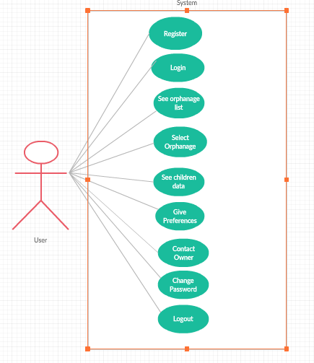
Fig 6.2.1: Use-case diagram for user module
6.2.2. Admin Module:
The administrator manages the database which consists of information regarding the different orphanages and can view/add/delete/update the information.
He can also view the users who have registered with the website.

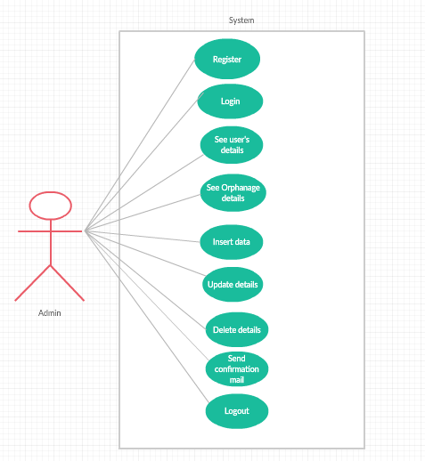
Fig 6.2.2: Use-case diagram for admin module

7. UML DIAGRAMS

The Unified Modelling Language (UML) is a standard language for writing software blue prints. The UML is a language for
- Visualizing
- Specifying
- Constructing
- Documenting the artefacts of a software intensive system.

Types of UML Diagrams:

Structural UML diagrams are:
- Class diagram
- Object diagram
- Component diagram
- Deployment diagram

Behavioural UML diagrams:
- Use case diagram
- Sequence diagram
- Collaboration diagram
- State chart diagram
- Activity diagram

7.1 CLASS DIAGRAM
A class diagram is at the heart of UML. It represents the core purposes of UML because it separates the design elements from the coding of the system. UML was set up as a standardized model to describe an object-oriented programming approach. Since classes are the building block of objects, class diagrams are the building blocks of UML.
The diagramming components in a class diagram can represent the classes that will actually be programmed, the main objects, or the interaction between class and object.
- Classes are typically modelled as rectangles with three sections: the top section for the name of the class, the middle section for the attributes of the class, the bottom section for the methods of the class.
- Attributes are the information stored about an object, while methods are the things an object or class.
The given diagram depicts the class diagram of the application.
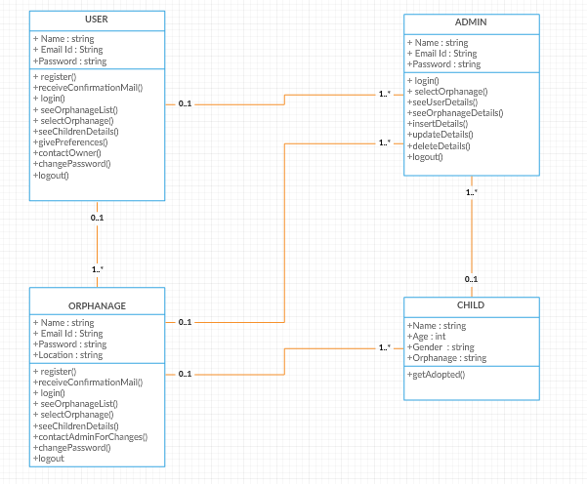
Fig 7.1: Class diagram
7.2 USE-CASE DIAGRAM:
The purpose of use case diagram is to capture the dynamic aspect of a system. However, this definition is too generic to describe the purpose, as other four diagrams (activity, sequence, collaboration, and State chart) also have the same purpose. We will look into some specific purpose, which will distinguish it from other four diagrams.
- The use case model defines the outside (actors) and inside (use case) of the system’s behaviour.
- Use case diagram is quite simple in nature and depicts two types of elements: one representing the business roles and the other representing the business processes.

The given diagram depicts the use-case diagram of the application.

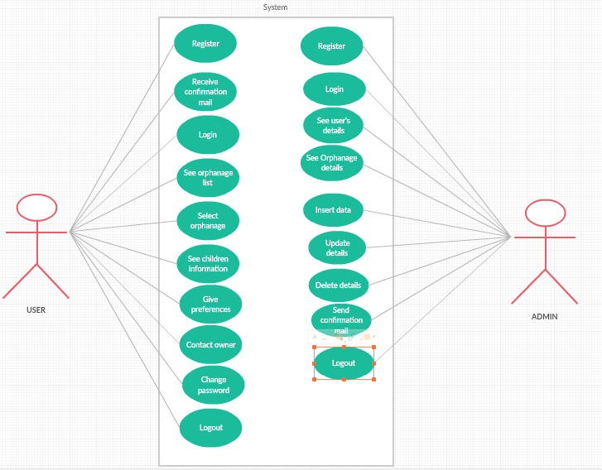
Fig 7.2: Use-case diagram

7.3 SEQUENCE DIAGRAM:
Sequence diagrams are a popular dynamic modelling solution. Dynamic modelling focuses on the interactions occurring within the system. Sequence diagrams specifically focus on the "lifelines" of an object and how they communicate with other objects to perform a function before the lifeline ends.
- UML sequence diagrams are used to represent the flow of messages, events and actions between the objects or components of a system. Time is represented in the vertical direction showing the sequence of interactions of the header elements, which are displayed horizontally at the top of the diagram.

The given diagram depicts the sequence diagram of the application.

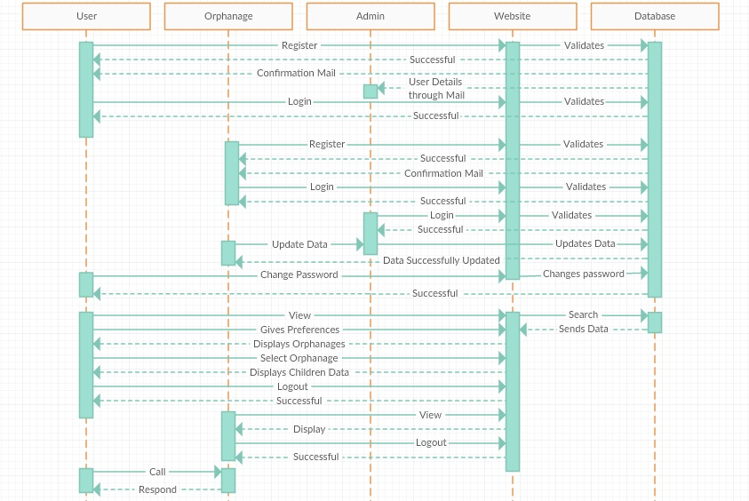
Fig 7.3: Sequence diagram

7.4 ACTIVITY DIAGRAM:
Activity diagram is another important diagram in UML to describe the dynamic aspects of the system.
Activity diagram is basically a flowchart to represent the flow from one activity to another activity. The activity can be described as an operation of the system.
The control flow is drawn from one operation to another. This flow can be sequential, branched, or concurrent. Activity diagrams deal with all type of flow control by using different elements such as fork, join, etc.
- Activity diagrams represent the business and operational workflows of a system.
- An Activity diagram is a dynamic diagram that shows the activity and the event that causes the object to be in the particular state.
The given diagram depicts the activity diagram of the application.
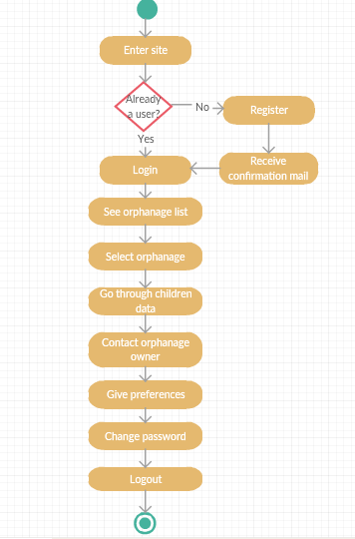
Fig 7.4.1: Activity diagram for user
The given diagram depicts the activity diagram of the application on the admin side.

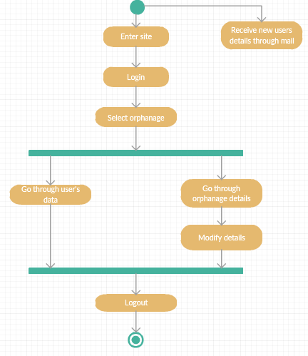
Fig 7.4.2: Activity diagram for admin

8. IMPLEMENTATION

  - WEB TECHNOLOGY:
    - HTML AND CSS:
The Hyper Text Markup Language (HTML) is used in most pages of the World Wide Web. HTML files contain both the primary text content and additional formatting markup, i.e. sequences of characters that tell web browsers how to display and handle the main content. The markup can specify which parts of text should be bold, where the headings are, or where tables, table rows, and table cells start and end. Though most commonly displayed by a visual web browser, HTML can also be used by browsers that generate audio of the text, by Braille readers that convert pages to a Braille format, and by accessory programs such as email clients.
HTML elements are delineated by tags, written using angle brackets. Tags such as <img /> and <input /> introduce content into the page directly. Others such as <p>...</p> surround and provide information about document text and may include other tags as sub-elements. Browsers do not display the HTML tags, but use them to interpret the content of the page.
The below image shows a part of HTML code of the application:
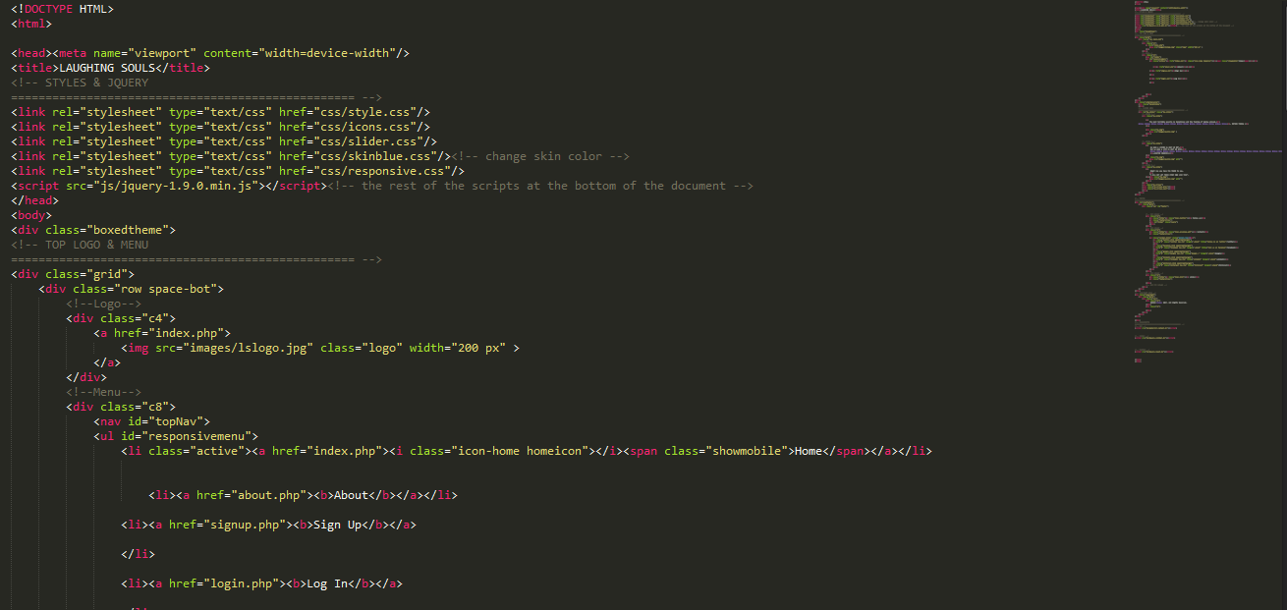
Fig 8.1.1.1: Sample HTML code of the application
Cascading Style Sheet (CSS) is a Web page derived from multiple sources with a defined order of precedence where the definitions of any style element conflict. The Cascading Style Sheet, level 1 (CSS1) recommendation from the World Wide Web Consortium (W3C), which is implemented in the latest versions of the Netscape and Microsoft Web browsers, specifies the possible style sheets or statements that may determine how a given element is presented in a Web page.
CSS comes in three types:
- In a separate file (external)
- At the top of a web page document (internal)
- Right next to the text it decorates (inline)
The below image shows a part of CSS code of the application:

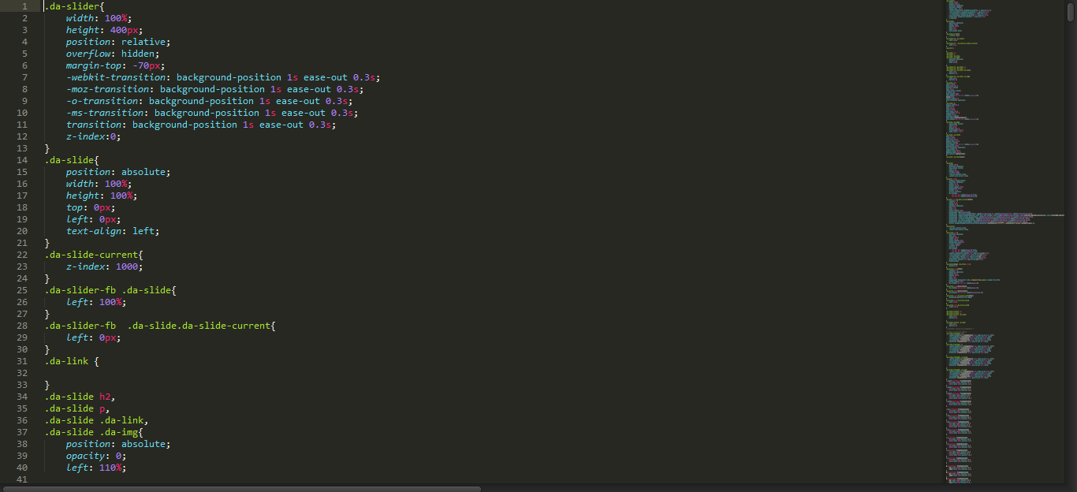
Fig 8.1.1.2: Sample CSS code of the application

    - PHP:
The PHP Hypertext Pre-processor (PHP) is a programming language that allows web developers to create dynamic content that interacts with databases. PHP is basically used for developing web based software applications. This tutorial helps you to build your base with PHP.

Common uses of PHP
- PHP performs system functions, i.e. from files on a system it can create, open, read, write, and close them.
- PHP can handle forms, i.e. gather data from files, save data to a file, through email you can send data, return data to the user.
- You add, delete and modify elements within your database through PHP.
- Access cookies variables and set cookies.
- Using PHP, you can restrict users to access some pages of your website.
- It can encrypt data.
The below image shows a part of PHP code of the application:

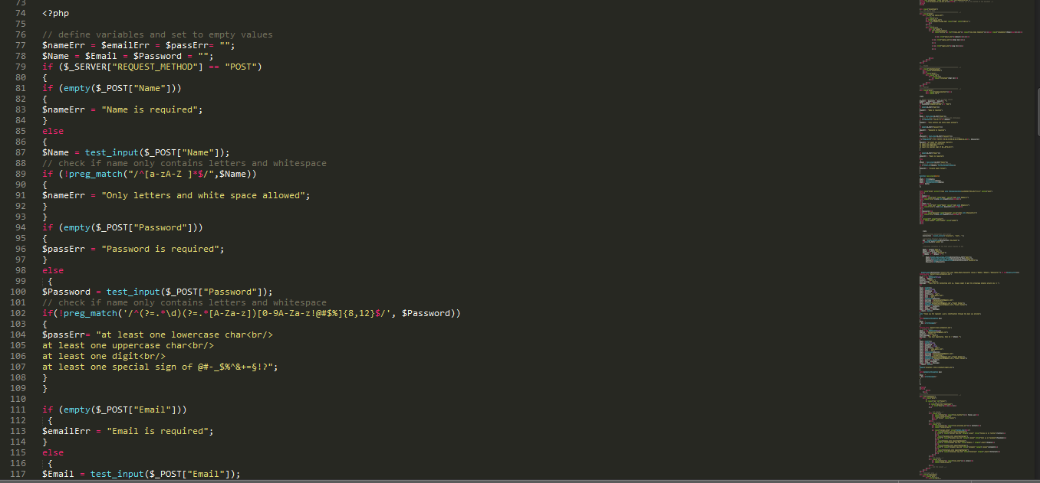
Fig 8.1.2: Sample PHP code of the application

    - WEB DEVELOPMENT KIT:
Web development tools allow web developers to test and debug their code. They are different from website builders and integrated development environments (IDEs) in that they do not assist in the direct creation of a webpage, rather they are tools used for testing the user interface of a website or web application.
Web development tools come as browser add-ons or built-in features in web browsers. The most popular web browsers today, Google Chrome, Firefox, Opera, Internet Explorer, UC browser and Safari have built-in tools to help web developers, and many additional add-ons can be found in their respective plug-in download centres.
Web development tools allow developers to work with a variety of web technologies, including HTML, CSS, the DOM, JavaScript, and other components that are handled by the web browser. Due to increasing demand from web browsers to do more, popular web browsers have included more features geared for developers.
The web's five most popular web browsers have support for web developer tools that allows web designers and developers to take a look at the makeup of their pages. These are all tools that are built into the browser and do not require additional modules or configuration.
- Google Chrome – Web Developer Tools
- Internet Explorer – F12 Web Developer Tools (As of version 8)
- Safari – Safari Web Development Tools (As of version 3)
- Firefox – F12 Web Console / Browser Console (since Firefox 4) (many add-ons also exist, including Firebug)
- Opera – Opera Dragonfly

Notepad++ is a text editor and source code editor for use with Microsoft Windows. Unlike Notepad, the built-in Windows text editor, it supports tabbed editing, which allows working with multiple open files in a single window. The project's name comes from the C increment operator.
Notepad++ is distributed as free software. At first the project was hosted on SourceForge.net, from where it has been downloaded over 28 million times, and twice won the Source Forge Community Choice Award for Best Developer Tool. The project was hosted on Tux Family (fr) from 2010 to 2015, since 2015 Notepad++ has been hosted on GitHub Notepad++ uses the Scintilla editor component.

Sublime Text is a proprietary cross-platform source code editor with a Python application programming interface (API). It natively supports many programming languages and markup languages, and functions can be added by users with plug-ins, typically community-built and maintained under free-software licenses.

The below image shows the view of sublime text-editor:
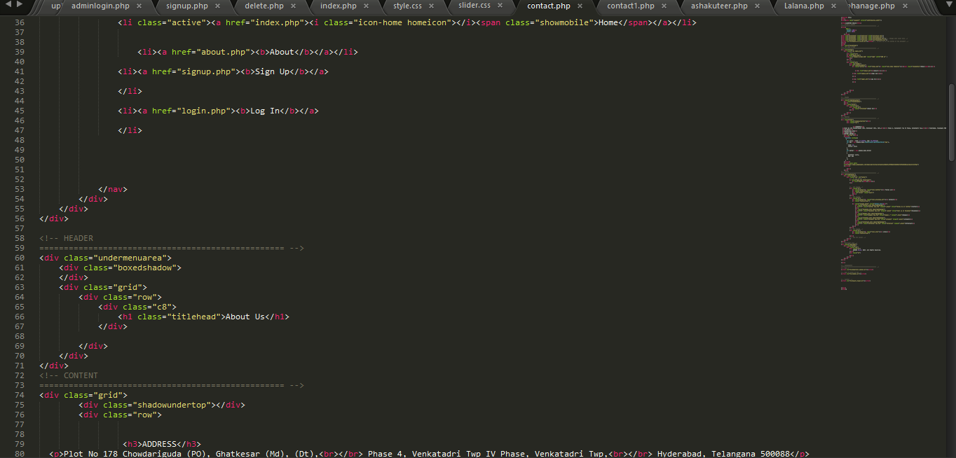
Fig 8.1.3: Sublime text editor

  - SOURCE CODE STRUCTURE:
8.2.1 FOLDERS:
- CSS: It is the folder that contains all the “.css” files that are created to provide styling to the website.

- FONTS: It is a folder which consists of different types of fonts that are used in the website.

- IMAGES: It is a folder which consists of all the images that are used in the website.

- JS: Folder that consists of all the java script files i.e. “.js” files.

- MAILER CLASS: It is a folder that consists of all the files which are used while sending a confirmation email to the user through Gmail after making a booking of the product.

8.2.2 FILES:
i) index.php: This file contains the source code for the home page of the website.

ii) about.php: This file contains the source code which tells the user about the website’s main purpose.

iii) signup.php: It is a file that consists of code which lets the user registers to the website and as the user registers it sends a confirmation mail to the user as well as a mail to the admin stating the user details.

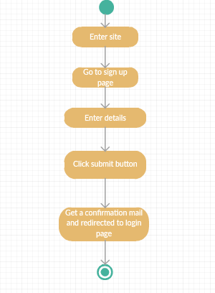
Fig 8.2.2 (iii): Activity diagram for signup.php

iv) login.php: This file contains the source code which lets the user to log in to the website.

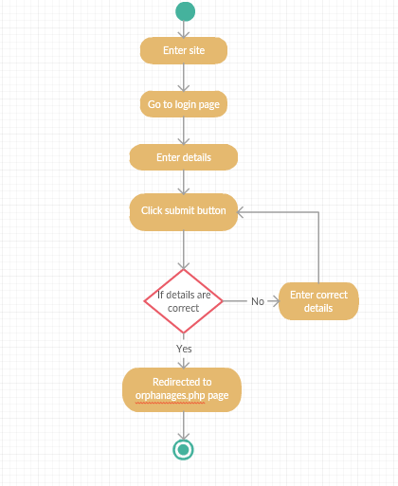
Fig 8.2.2 (iv): Activity diagram for login.php

v) orphanages.php: This file contains the source code which shows the list of the orphanages from which user can select any orphanage.
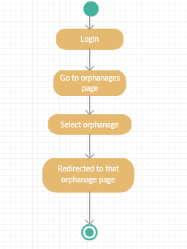
Fig 8.2.2 (v): Activity diagram for orphanages.php
vi) orphanagename.php: This file contains the source code which shows all the information related to all the children staying in the orphanage selected by the user.
vii) preferences.php: This file contains the source code of a form in which user enters the preferences of a child which he/she wants to adopt such as age and gender.
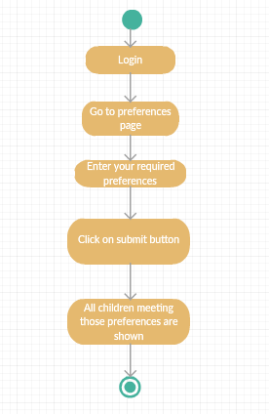
Fig 8.2.2 (vi): Activity diagram for preferences.php
viii) pwchange.php: This php file contains the source code for a form to change the user’s password.
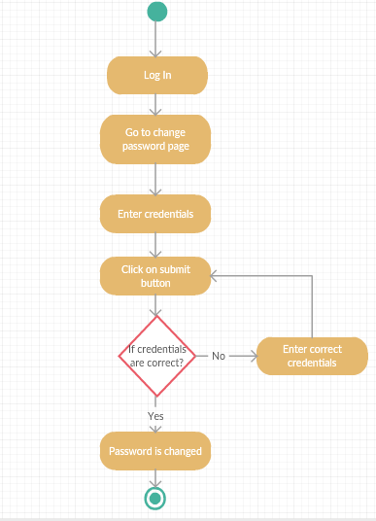
Fig 8.2.2 (viii): Activity diagram for pwchange.php
ix) contact.php: This php file contains the source code which contains the orphanage contact information along with a map which shows the location of that particular orphanage.
x) logout.php: This php file contains the source code for letting a user to log out of the website.
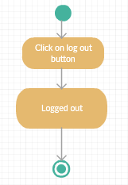
Fig 8.2.2 (x): Activity diagram for logout.php
xi) adminlogin.php: This file contains the source code which lets the admin to login to the website to see the database information.
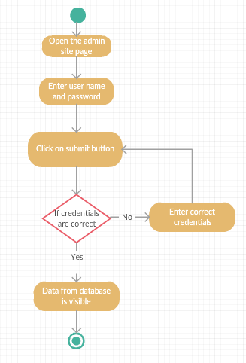
Fig 8.2.2 (xi): Activity diagram for adminlogin.php
xii) show.php: This file contains the source code to make the admin available with two buttons - user details and orphanage details.
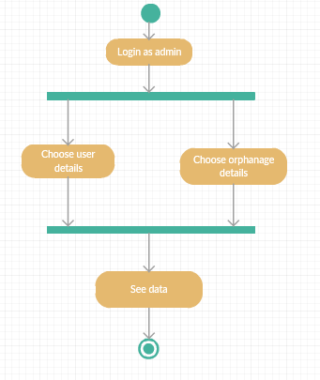
Fig 8.2.2 (xii): Activity diagram for show.php

xiii) displayuser.php: This file contains the source code which presents the admin with all the registered user’s information.

xiii) selectorphanage.php: This file contains the source code which lets the admin to enter one orphanage name whose data he wants to see or modify.

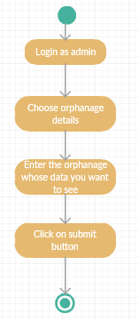
Fig 8.2.2 (xiii): Activity diagram for selectorphanage.php

xiv) displayorphanage.php: This file contains the source code which shows the information of a particular orphanage which is entered in selectorphanage.php. It contains three options to insert, update and delete any child information.

xv) insert.php: This file contains the source code which lets the user insert any new child information.
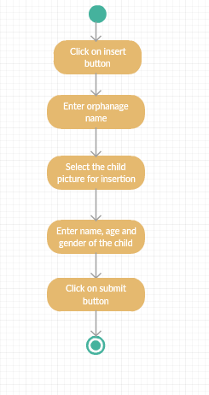
Fig 8.2.2 (xv): Activity diagram for insert.php
xvi) upupdatedetails.php: This file contains the source code which lets the admin to update any information of a child.
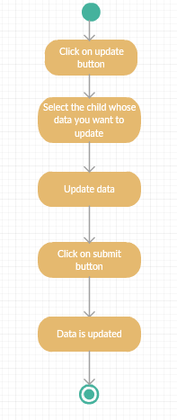
Fig 8.2.2 (xvi): Activity diagram for updatedetails.php
xvii) delete.php: This file contains the source code which lets the admin to delete any child information.
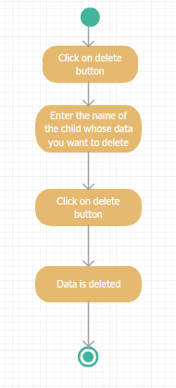
Fig 8.2.2 (xvii): Activity diagram for delete.php

xviii) adminlogout.php: This file contains the source code which lets the admin to log-out lf the website.
Fig 8.2.2 (xviii): Activity diagram for adminlogout.php

9. TESTING
  - INTRODUCTION:

The purpose of testing is to discover errors. Testing is the process of trying to discover every conceivable fault or weakness in a work product. It provides a way to check the functionality of components, sub-assemblies, assemblies and/or a finished product. It is the process of exercising software with the intent of ensuring that the software system meets its requirements and user expectations and does not fail in an unacceptable manner. There are various types of test. Each test type addresses a specific testing requirement.

9.2 OBJECTIVES OF TESTING:
- Finding defects which may get created by the programmer while developing the software.
- Gaining confidence in and providing information about the level of quality.
- To prevent defects.
- To make sure that the end result meets the business and user requirements.
- To ensure that it satisfies the BRS that is Business Requirement Specification and SRS that is System Requirement Specifications.
- To gain the confidence of the customers by providing them a quality product.

  - TYPES OF TESTING:
There are many approaches available in software testing.
- BLACK BOX TESTING:
Black box testing is a testing technique that ignores the internal mechanism of the system and focuses on the output generated against any input and execution of the system. It is also called functional testing. Black box testing is often used for validation.

- WHITE BOX TESTING:
White box testing is a testing technique that takes into account the internal mechanism of a system. It is also called structural testing and glass box testing.
White box testing is often used for verification.

- UNIT TESTING:
Unit testing is the testing of an individual unit or group of related units. It falls under the class of white box testing. It is often done by the programmer to test that the unit he/she has implemented is producing expected output against given input.

- INTEGRATION TESTING:
Integration testing is testing in which a group of components are combined to produce output. Also, the interaction between software and hardware is tested in integration testing if software and hardware components have any relation. It may fall under both white box testing and black box testing.

- FUNCTIONAL TESTING:
Functional testing is the testing to ensure that the specified functionality required in the system requirements works. It falls under the class of black box testing.

- SYSTEM TESTING:
System testing is the testing to ensure that by putting the software in different environments (e.g., Operating Systems) it still works. System testing is done with full system implementation and environment. It falls under the class of black box testing.

- VALIDATION TESTING:
This testing concentrates on confirming that the software is error-free in all respects. All the specified validations are verified and the software is subjected to hard-core testing. It also aims at determining the degree of deviation that exists in the software designed from the specification; they are listed out and are corrected.

- PERFORMANCE TESTING:
Performance testing is the testing to assess the speed and effectiveness of the system and to make sure it is generating results within a specified time as in performance requirements. It falls under the class of black box testing.
The below table shows the test cases on the user site:
Test Case ID | Test Case | Function being Tested | Initial state | Input | Output | Status
1. | Signup | All the details entered are stored in database or not. | Signup  page | Name, Email and Password | Login page | Successful
2. | Login | Verify username and password | Login page | Username and password | List of orphanages | Successful
3. | Select orphanage | - | Page with list of orphanages | - | Information of children staying in that orphanage is shown | Successful
4. | Preferences form | All the details entered are checked from database or not. | Preferences page | Age and gender | Children matching with the given preferences are shown | Successful
5. | Change password form | Password is changed or not. | Change password page. | Old password, new password and confirm new password. | Login page | Successful
The below table shows the test cases on the admin site:
Test Case ID | Test Case | Function being Tested | Initial state | Input | Output | Status
1. | Login | Verify username and password | Login page | Username and password | Details page | Successful
2. | Select user details | - | Details page | - | Information of registered users is shown | Successful
4. | Select Orphanage details | Orphanage name which is entered is checked with database or not. | Details page | Name of the orphanage whose details admin wants to see. | Information of that particular orphanage is shown. | Successful
5. | Insert data | Data is inserted or not. | Insert page | Orphanage name, picture of the child, name, age and gender. | Data is inserted for the particular orphanage. | Successful
6. | Update data | Data is modified or not. | Update details page. | Data which the admin wants to modify. | Data is updated. | Successful
7. | Delete data | Data is deleted or not. | Delete page | Name of the child whose record you want to delete. | Data is deleted. | Successful

10. SCREENSHOTS

  - INDEX PAGE:
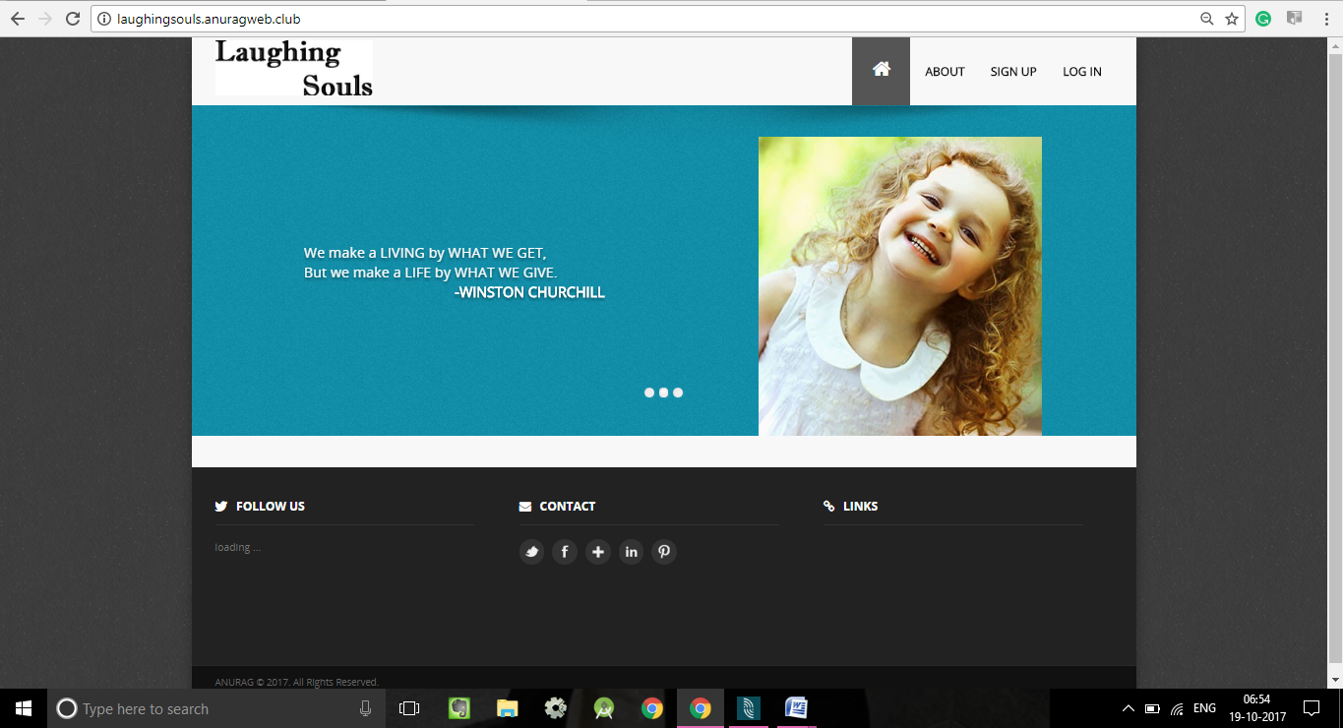
Fig 10.1: Index Page screenshot
  - ABOUT PAGE:
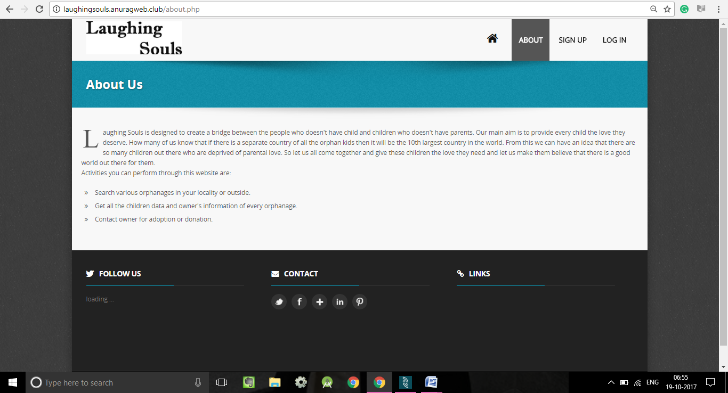
Fig 10.2: Login screenshot
  - SIGNUP PAGE:
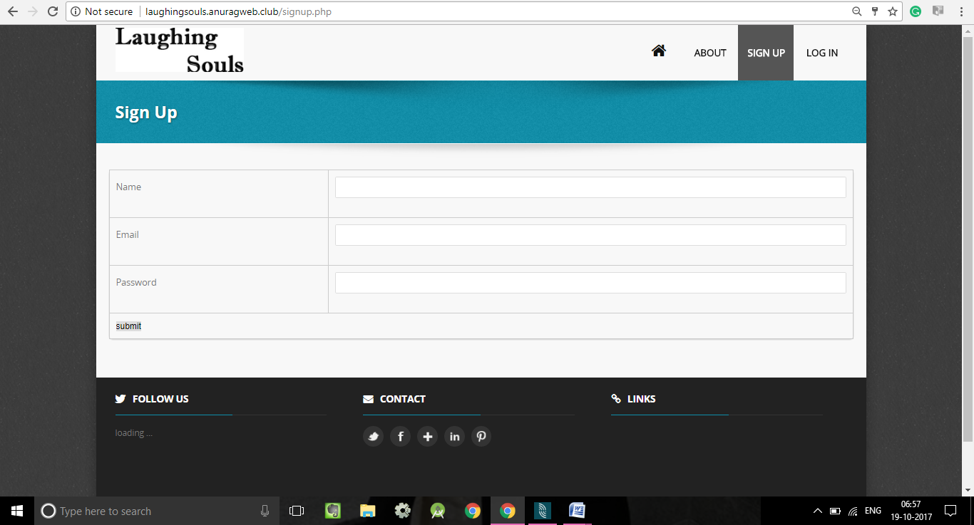
Fig 10.3: Signup Page screenshot

  - LOGIN PAGE:
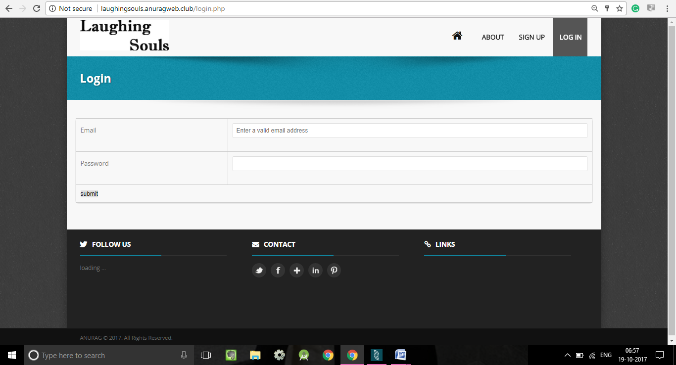
Fig 10.4: Index Page screenshot

  - LIST OF ORPHANAGES PAGE:
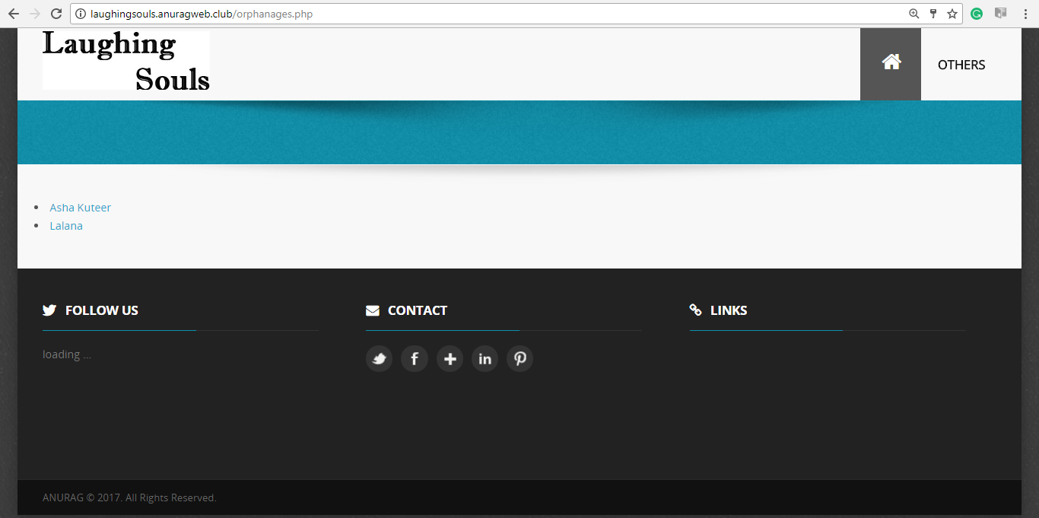
Fig 10.5: Orphanages Page screenshot

  - CHILDREN DETAILS PAGE:
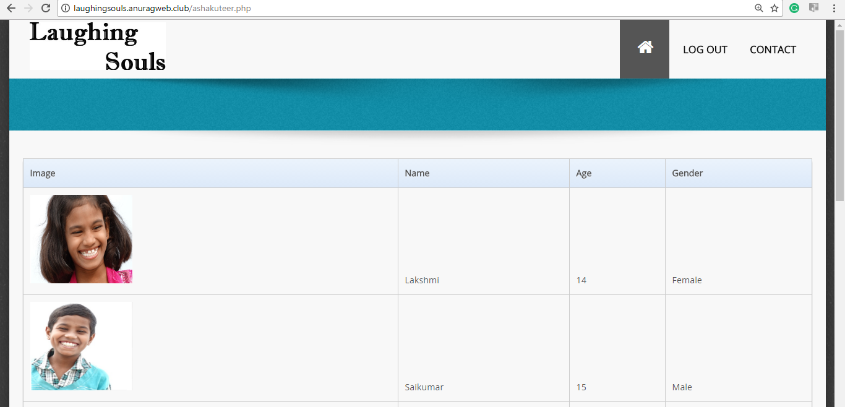
Fig 10.6: Children details screenshot

  - PREFERENCES PAGE:
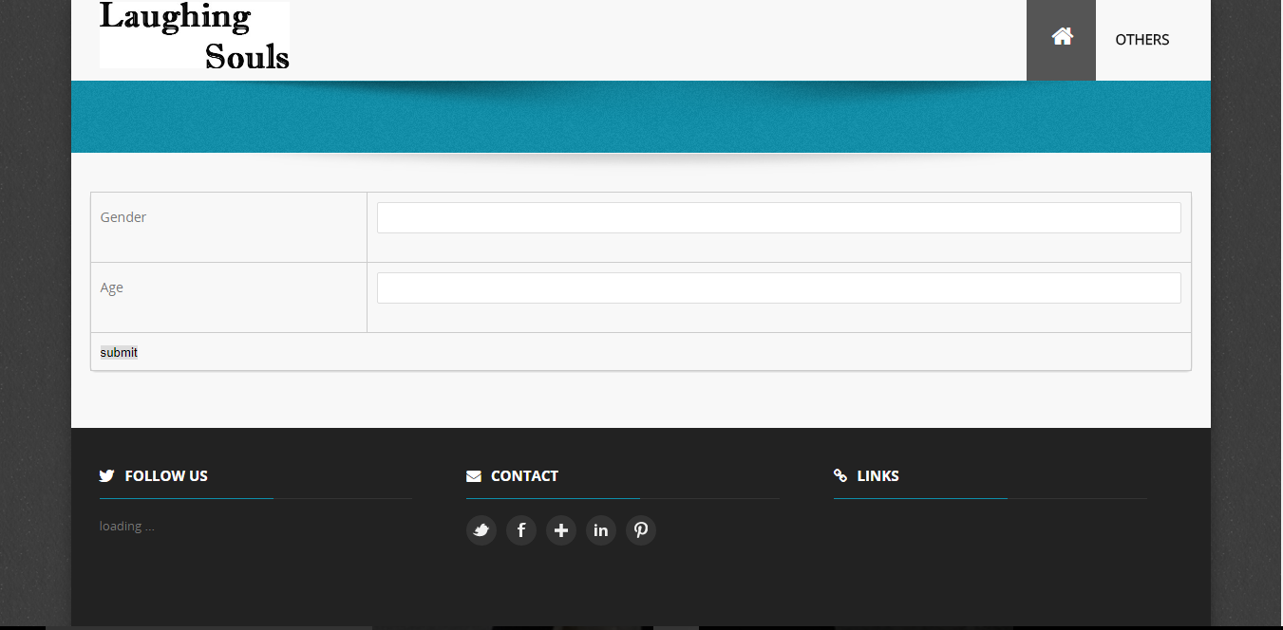
Fig 10.7: Preferences Page screenshot

  - CHANGE PASSWORD PAGE:

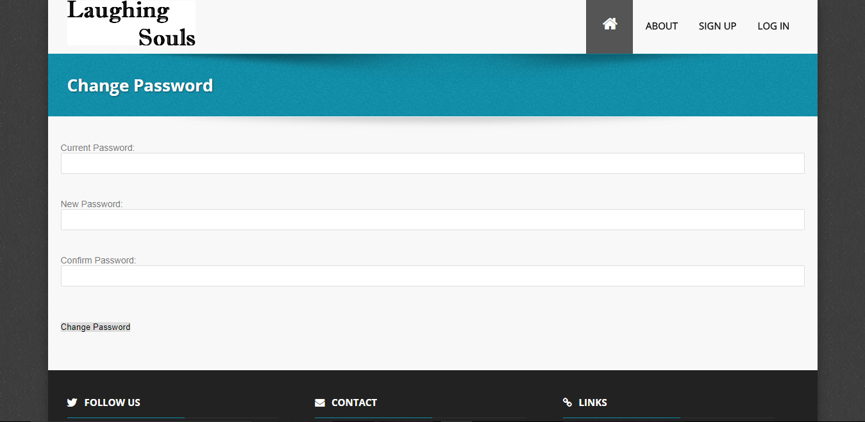
Fig 10.8: Change password Page screenshot

  - CONTACT PAGE:
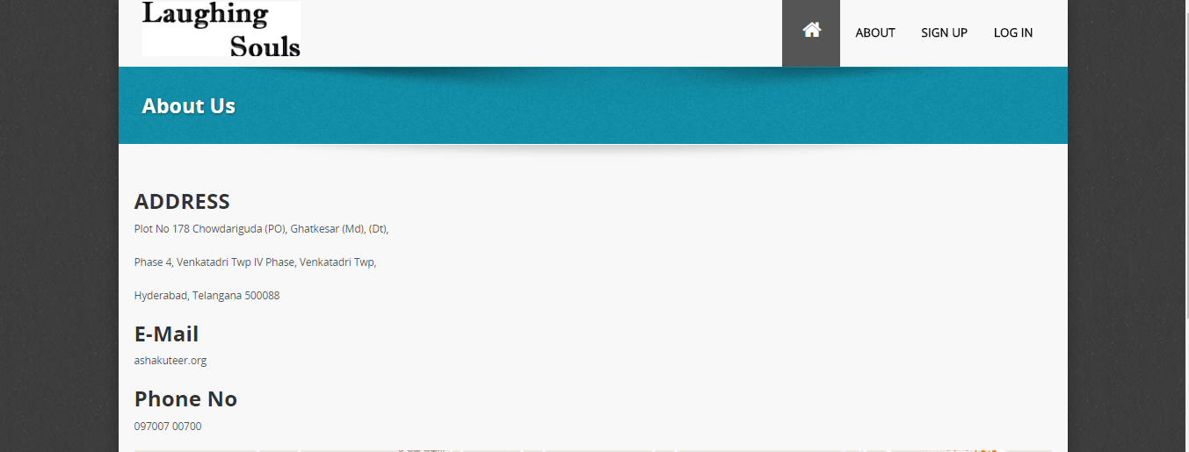

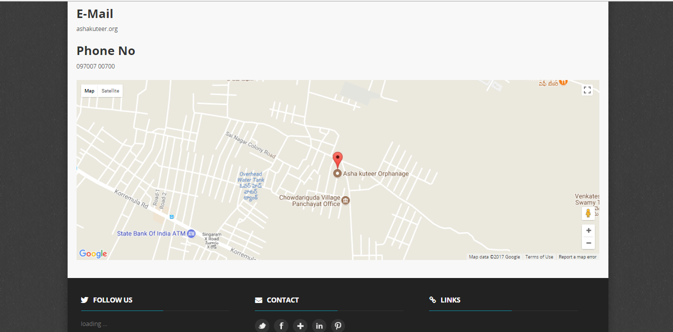
Fig 10.9: Contact Page screenshot

10.10 ADMIN LOGIN PAGE:
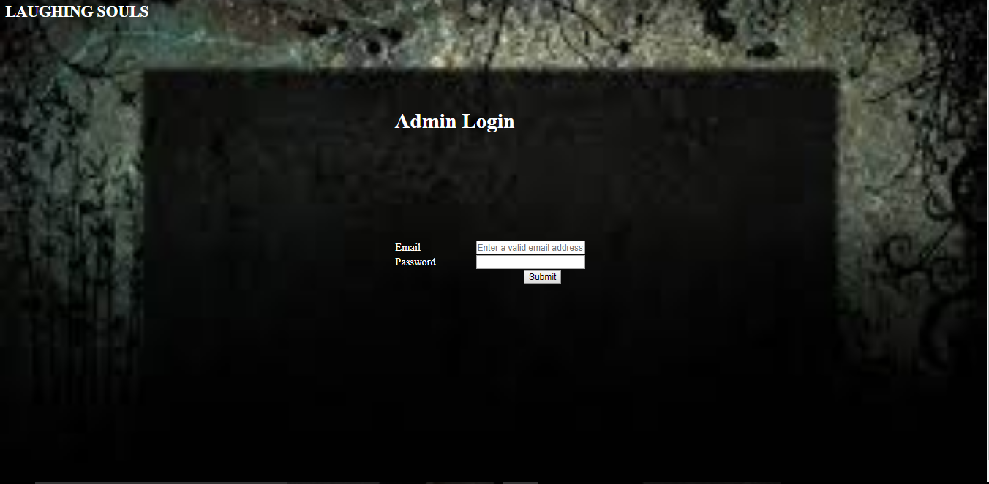
Fig 10.10: Admin lo Page screenshot

10.11 CHOOSE OPTION PAGE:
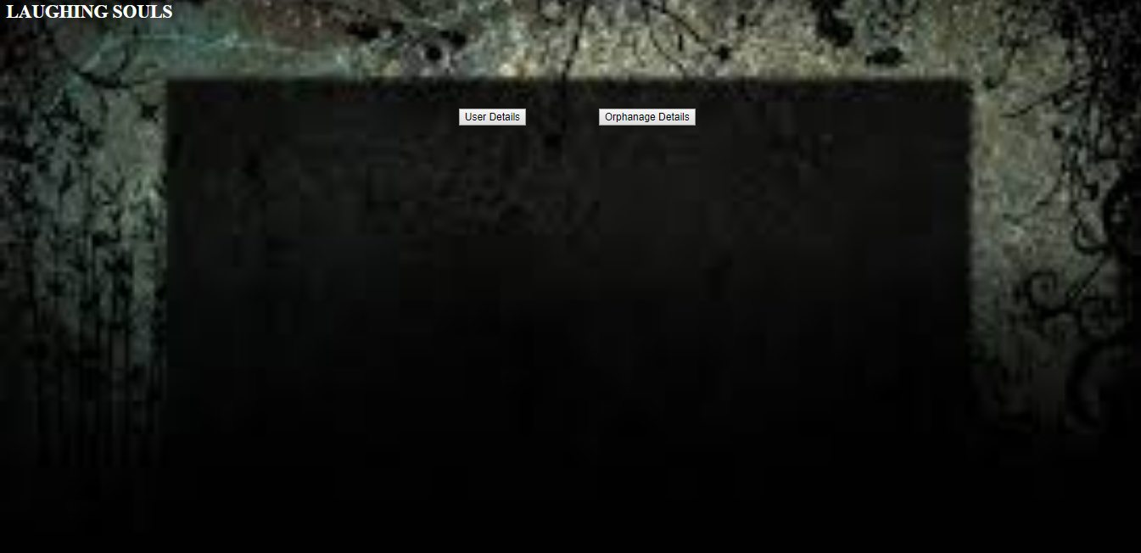
Fig 10.11: Choose option Page screenshot

  - USER DETAILS PAGE:
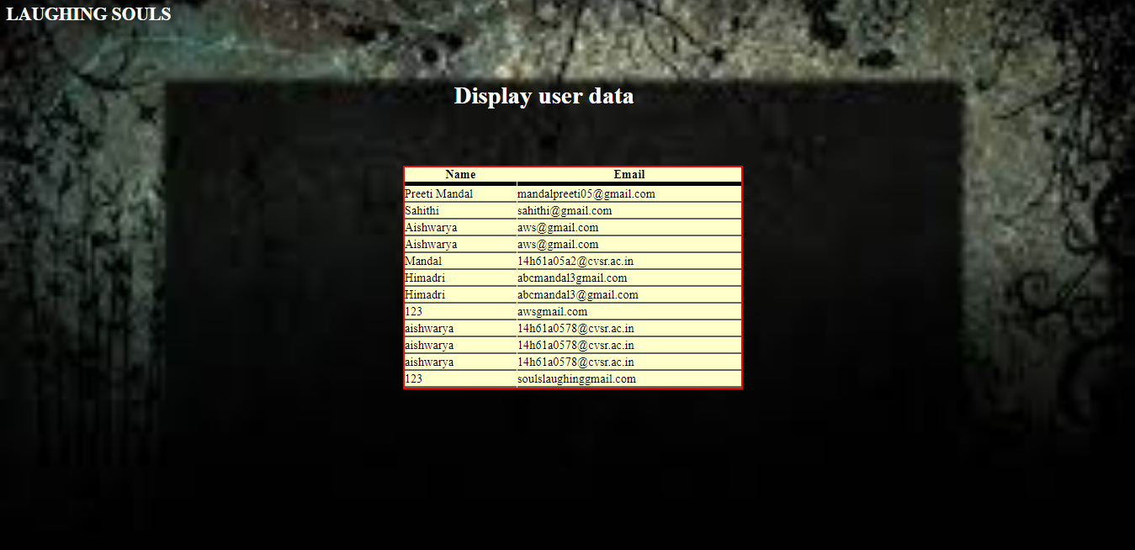
Fig 10.12:User details Page screenshot

  - ORPHANAGE DETAILS PAGE:
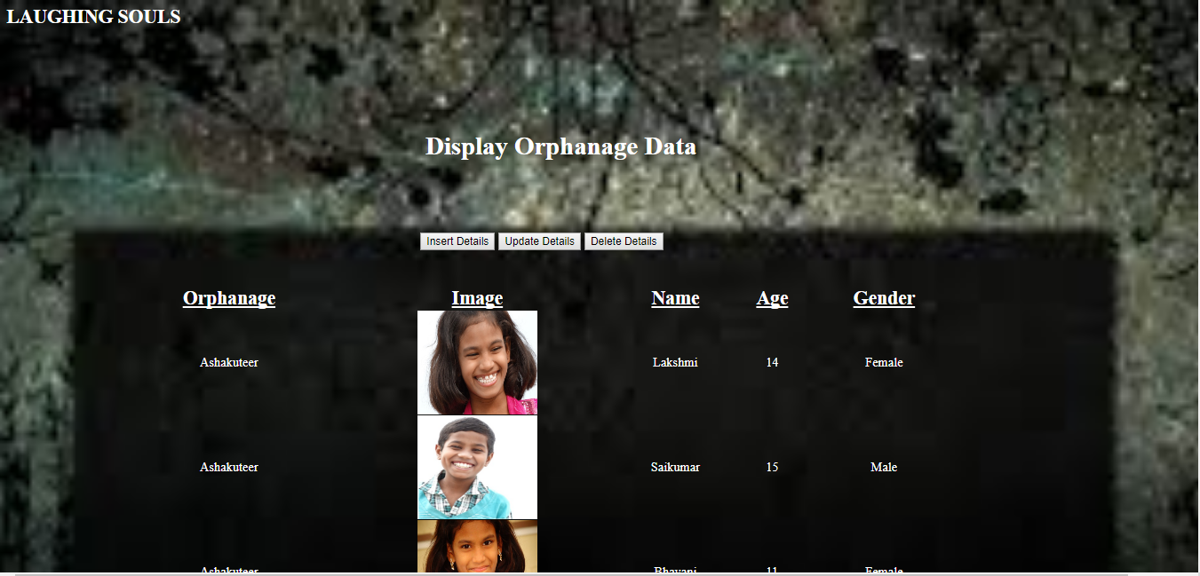
Fig 10.1: Orphanage details screenshot

  - INSERT PAGE:
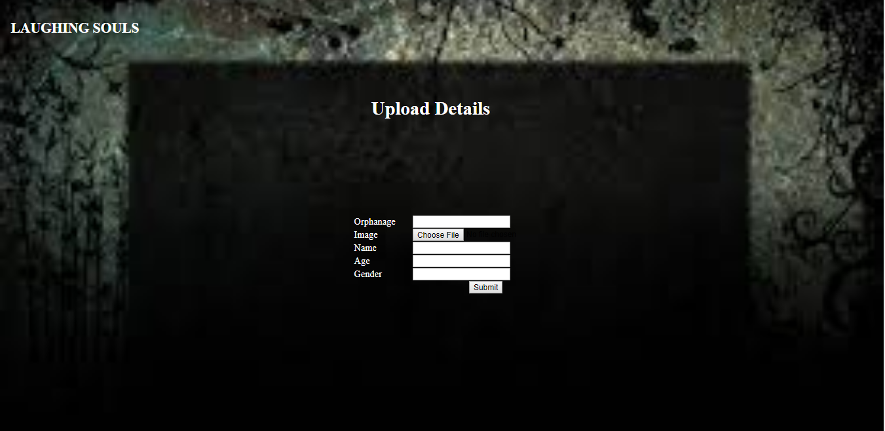
Fig 10.14: Insert page screenshot

  - UPDATE PAGE:
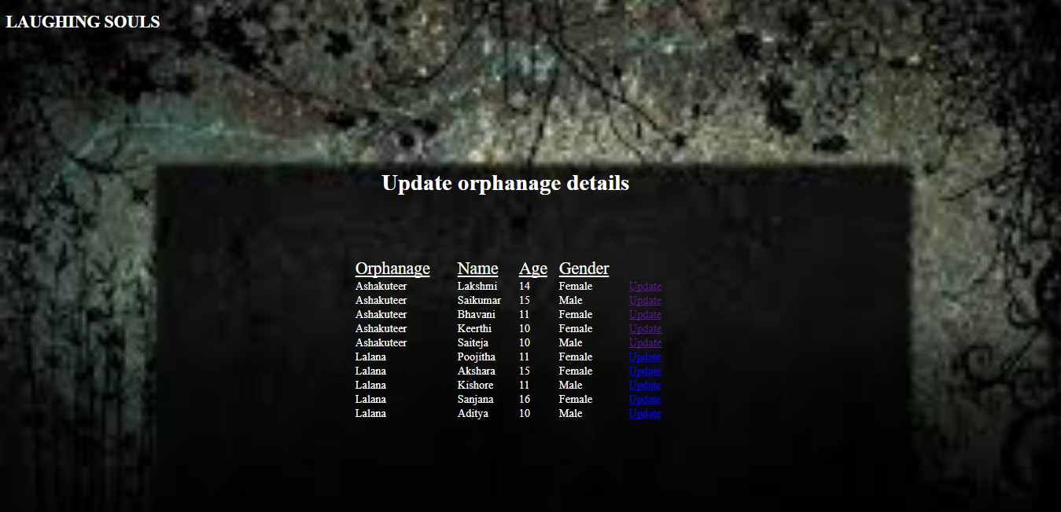

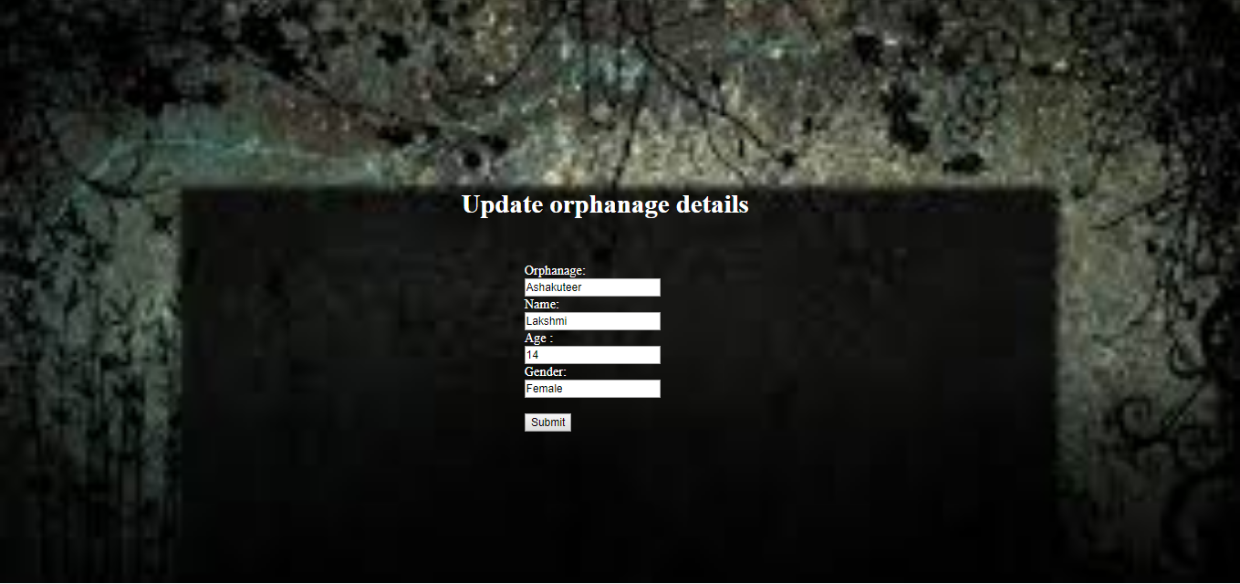
Fig 10.15: Update Page screenshot

  - DELETE PAGE:
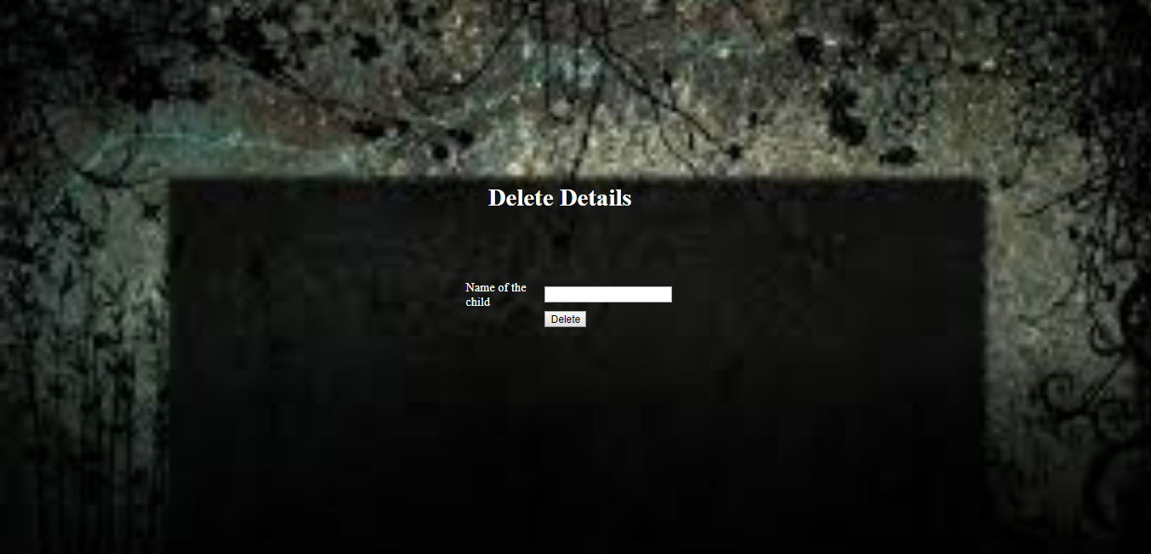
Fig 10.16: Delete Page screenshot

  - TABLES IN PHP MYADMIN:
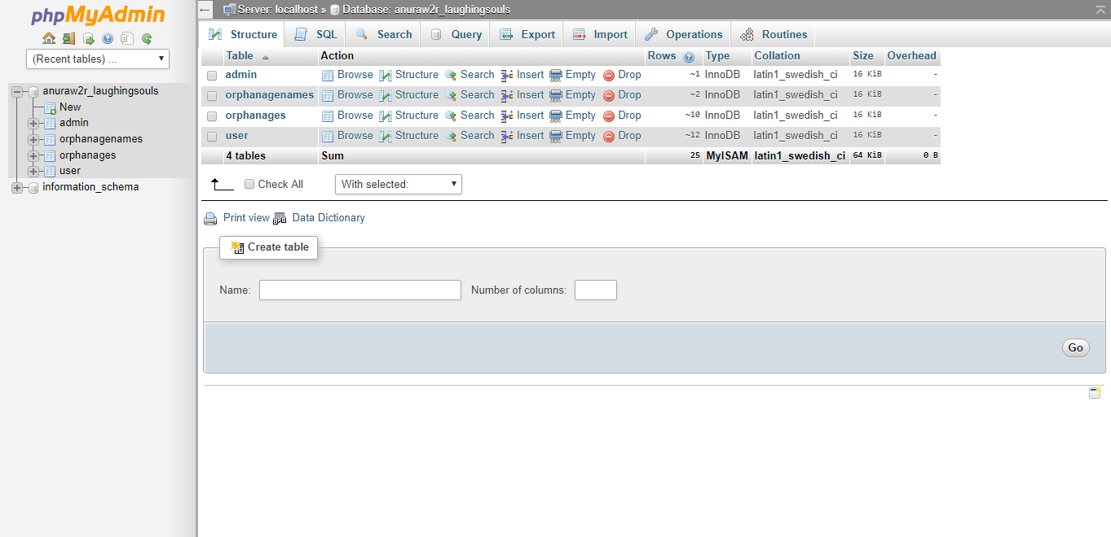
Fig 10.17: Tables in database

  - ADMIN TABLE:
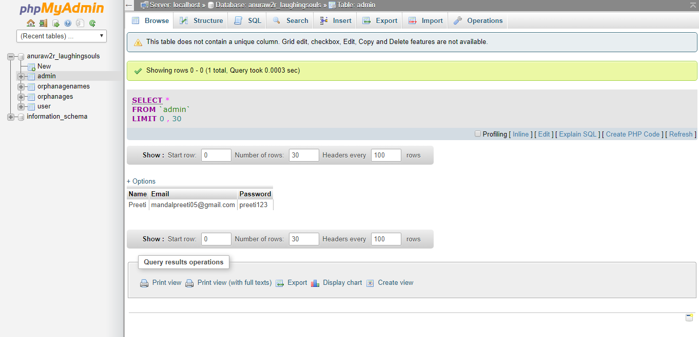
Fig 10.18: User database table screenshot

  - USER TABLE:
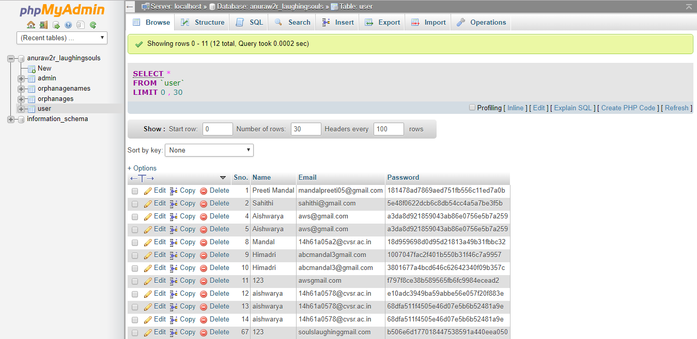
Fig 10.19: User database table screenshot

  - ORPHANAGES TABLE:
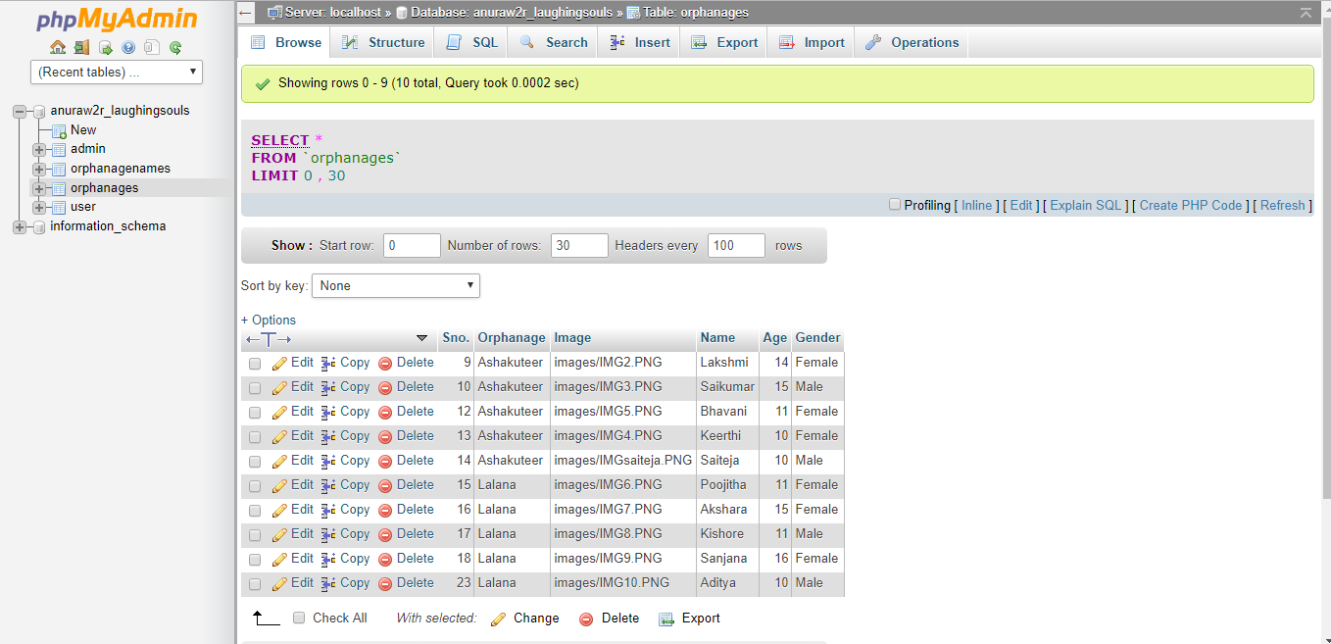
Fig 10.20: Orphanages database table screenshot

11. DEPLOYMENT

Deployment diagram is a structure diagram which shows architecture of the system as deployment (distribution) of software artifacts to deployment targets.

Artifacts represent concrete elements in the physical world that are the result of a development process. Examples of artifacts are executable files, libraries, archives, database schemas, configuration files, etc.

Deployment target is usually represented by a node which is either hardware device or some software execution environment. Nodes could be connected through communication paths to create networked systems of arbitrary complexity.

Note, that components were directly deployed to nodes in UML 1.x deployment diagrams. In UML 2.x artifacts are deployed to nodes, and artifacts could manifest (implement) components. Components are deployed to nodes indirectly through artifacts.

Deployment diagrams could describe architecture at specification level (also called type level) or at instance level (similar to class diagrams and object diagrams).

Specification level deployment diagram shows some overview of deployment of artifacts to deployment targets, without referencing specific instances of artifacts or nodes.

Instance level deployment diagram shows deployment of instances of artifacts to specific instances of deployment targets. It could be used for example to show differences in deployments to development, staging or production environments with the names/ids of specific build or deployment servers or devices.

Some common types of deployment diagrams are:

- Implementation (manifestation) of components by artifacts
- Specification level deployment diagram
- Instance level deployment diagram
- Network architecture of the system

11.1 DEPLOYMENT DIAGRAM:
The below figure shows the deployment diagram of the application:

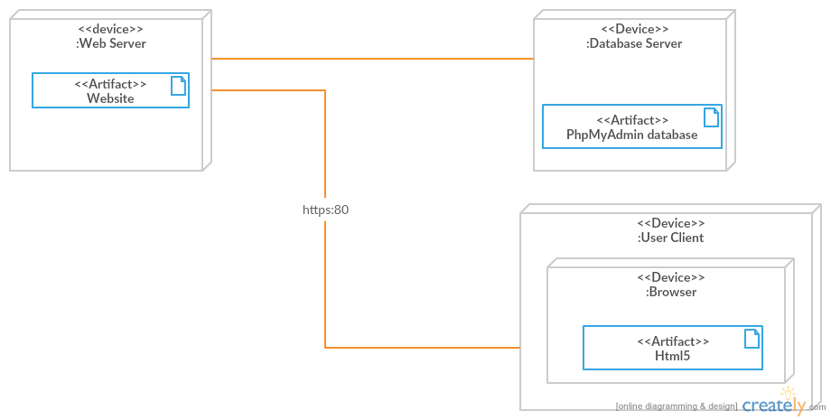
Fig 13.1: Deployment diagram

- CONCLUSION AND FUTURE ENCHANCEMENTS

Our website enables a user to search for a orphanage for adoption. He can select from a list of orphanages.
Each orphanage provides the user with the list of children and their details. For getting the orphanages list first the user should register with the website.
They can also see the children list according to their preferences of age and gender. User can also contact the orphanage owner by going to the contact page of any orphanage.
Our further enhancement to the website would be that the user is allowed to pay donation online. We would provide the admin with more privileges.
We would also provide Rating for each orphanage and letting the user know how good is the orphanage.

- BIBLIOGRAPHY

- The Unified Modelling Language Users guide by Grady Booch.
- Software Engineering, A practitioner’s approach by Roger S Pressman.
- Software Project Management by Walker Royce.
- http://www.w3schools.com/
- https://creately.com/
- https://secure.php.net/
- http://stackoverflow.com/

